**Letters and falses resizing procedure**

The original stimuli were in a 400 by 400 canvas.

The first step was to trim the canvas, using the trimming function in photoshop as follows:

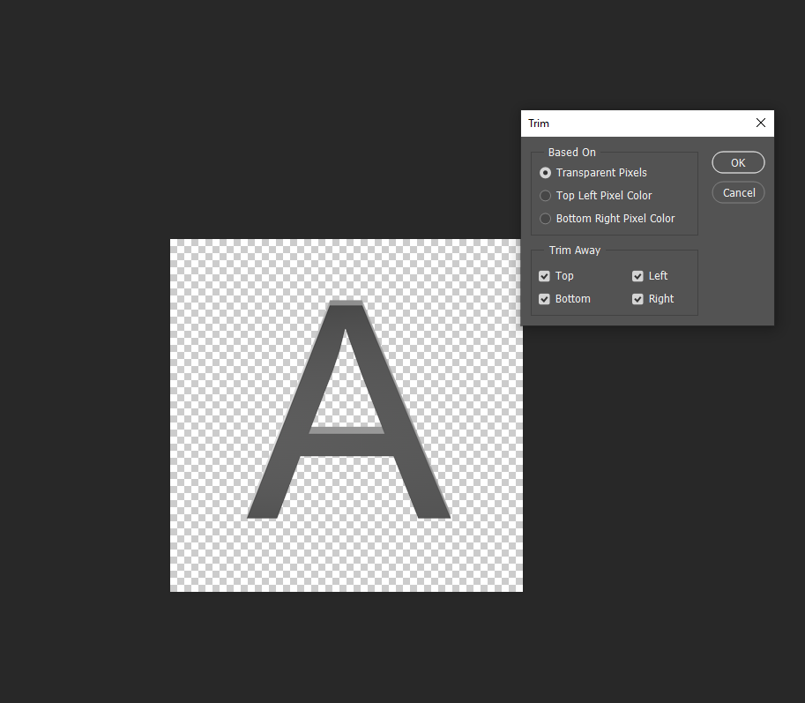

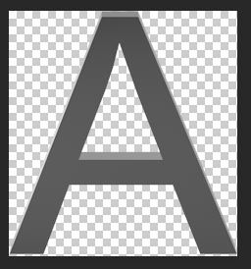Resulting in

I did so for each picture in each orientation.

I then inspected the dimensions of the same stimulus in the different orientations and found the orientation having the largest value for one of the dimension.

Here you can see a piece of the table I created to do so:

The bold cells represent the orientation with the largest value in one of the dimension.

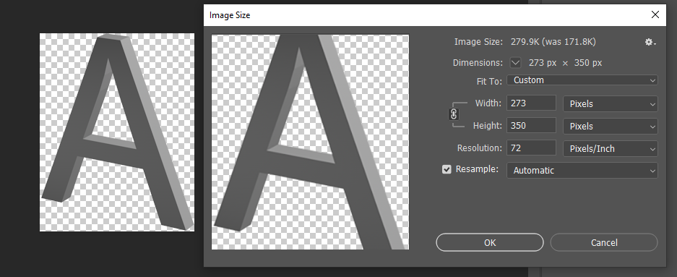I then opened the said stimulus in photoshop, and resized it so that the largest dimension reaches 350 pixel. In the example of the letter A, this gives:

So this picture was resized by a specific factor that can be found by switching the unit to percent after rescaling, like so: 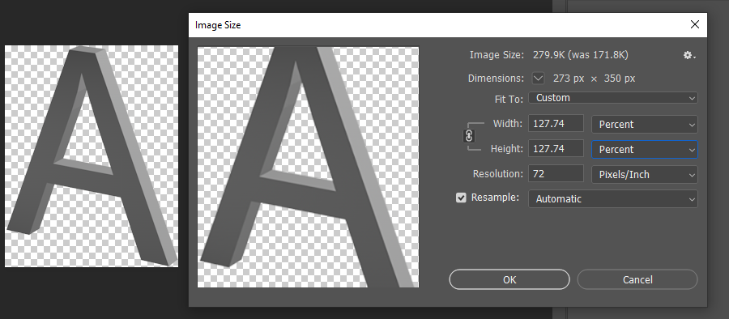

This corresponds to the Rescale factor in the table.

I then used the same rescale factor to rescale the stimulus in the two other orientations:

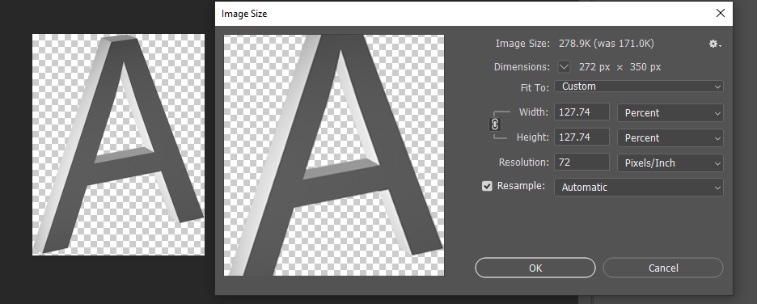

The final step was to add a canvas of 350 by 350 to each stimulus to make the size consistent across all.

To do so, I used the canvas size function in photoshop, like so

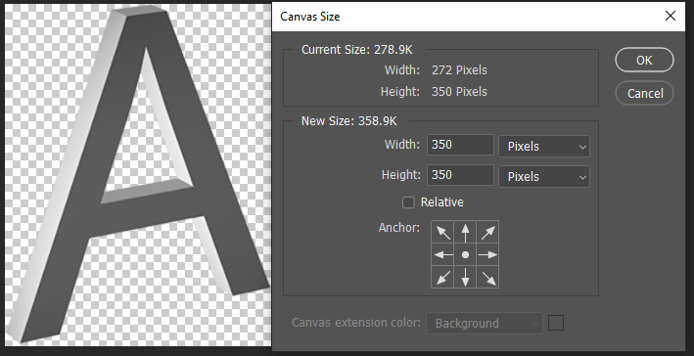

The stimuli were then saved.